**Ideation Phase**

**Brainstorm & Idea Prioritization**

|  |  |
| --- | --- |
| Date | 16 November 2022 |
| Team ID | PNT2022TMID51374 |
| Project Name | A Gesture-based Tool for Sterile Browsing of Radiology Images |
| Maximum Marks | 4 Marks |

**Brainstorm & Idea Prioritization:**

**Step-1: Team Gathering, Collaboration and Select the Problem Statement**

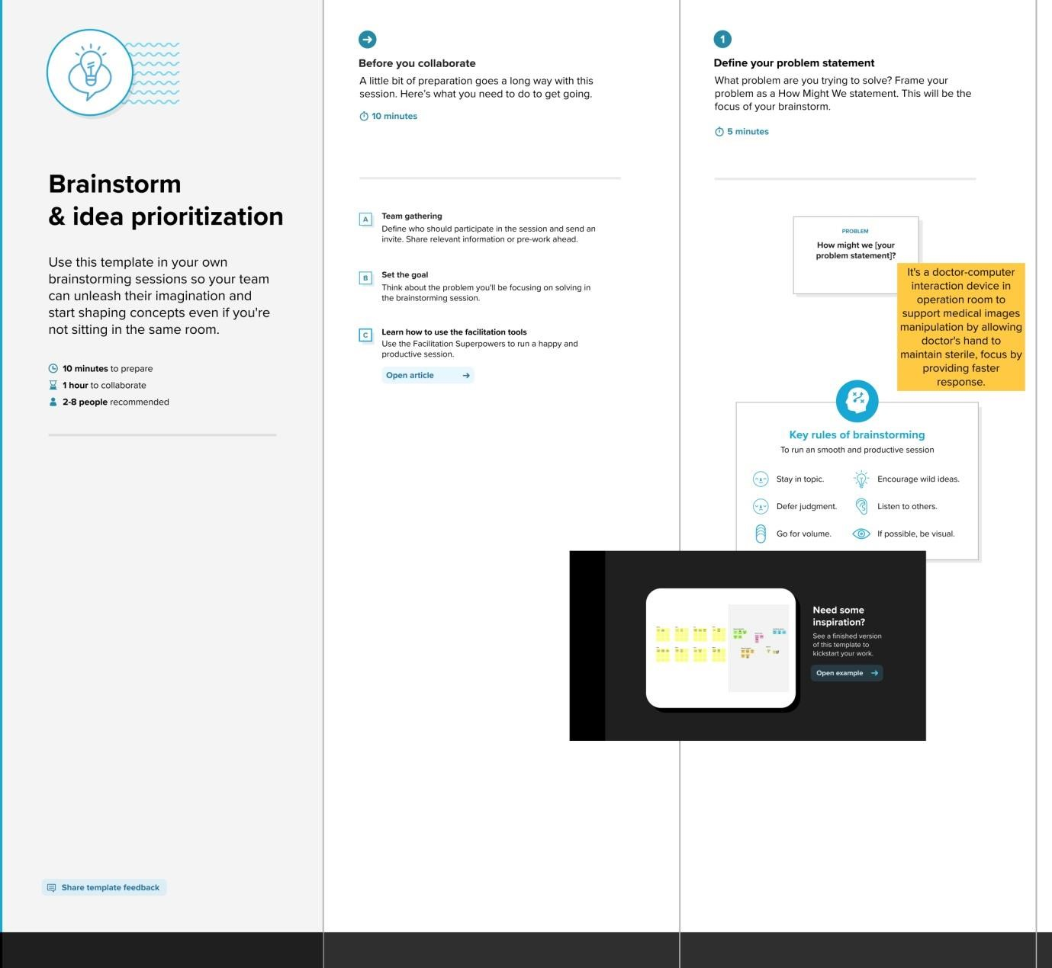

**Step-2: Brainstorm, Idea Listing and Grouping**

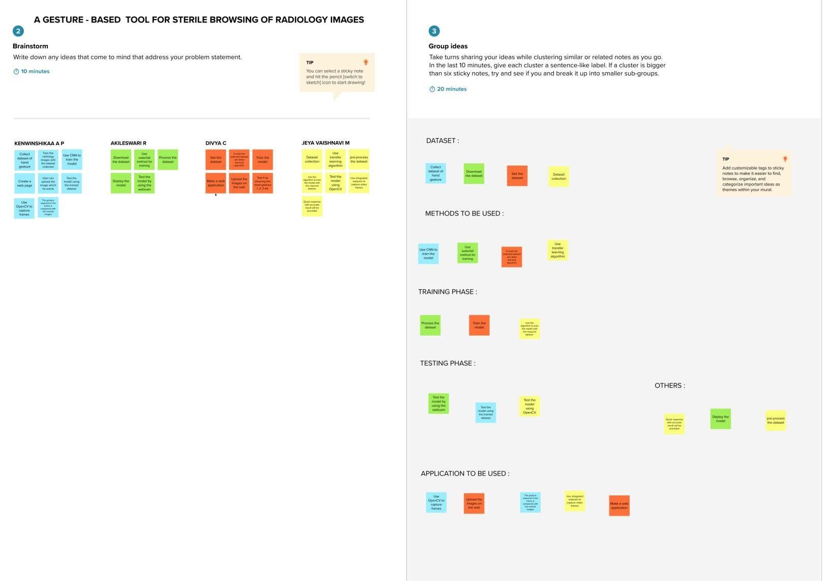

**Step**

**-**

**3:**

**Idea Prioritization**

